# Resident Evil Part 2

This is the continuation of **Resident Evil Part 1**. Your primary task will be to create a proper **Register/Login** system.

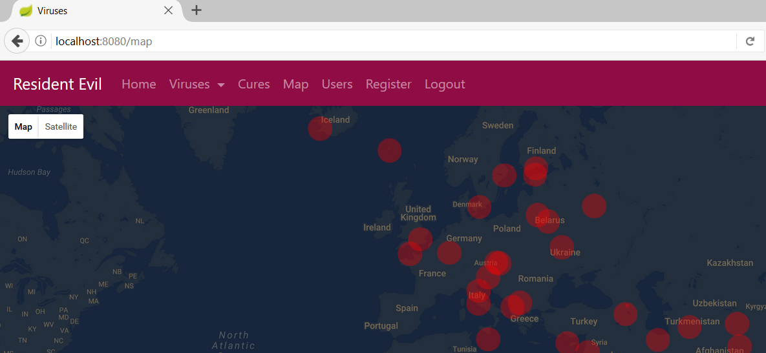

## Register

Create a **register** option in the menu. It should save **users** in the database. Make the necessary **validations**.

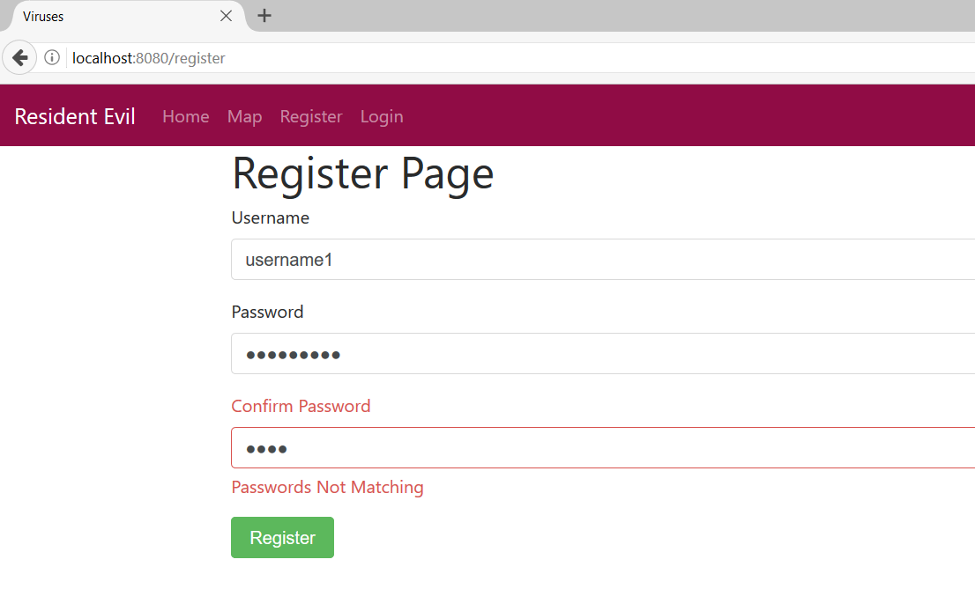

## Log In

Create a **login** page with **Remember Me** option.

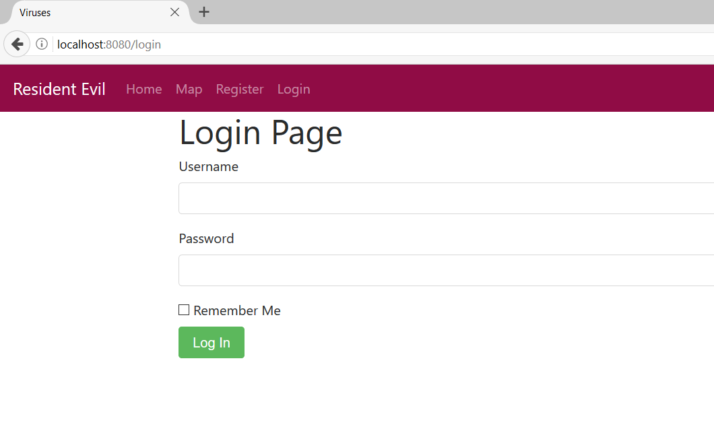

## Roles

There should be three main **roles** in your application:

* ADMIN – should be able to access **everything**
* CHEMIST – should be able to access **/viruses/ {and everything after it}**
* MEDIC - should be able to access **/cures/ {and everything after it}**

Assign the roles from the **database** for now.

## Cures

Create a page for cures that should be accessible only from **Admins and Medics**. It should show all the viruses with possibility to **delete** them.

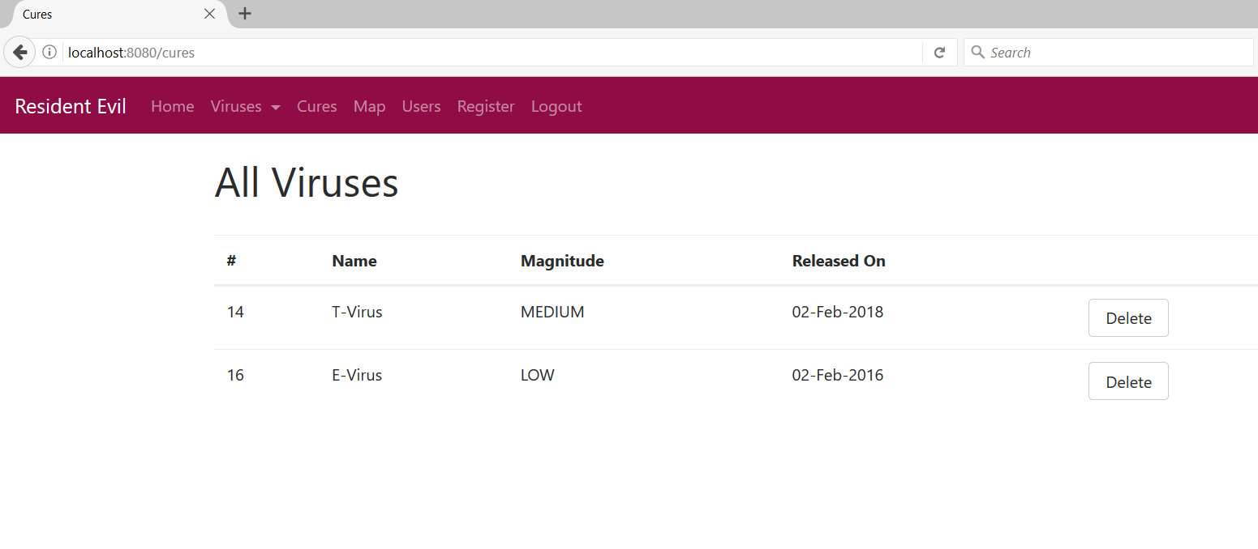

## Custom Authorization

Chemists can access the **viruses**. However, they cannot delete them. (They are bad and are not supposed to turn good). Only **Admins** can delete viruses from the viruses’ page. Create a **page** to handle **access denials**.

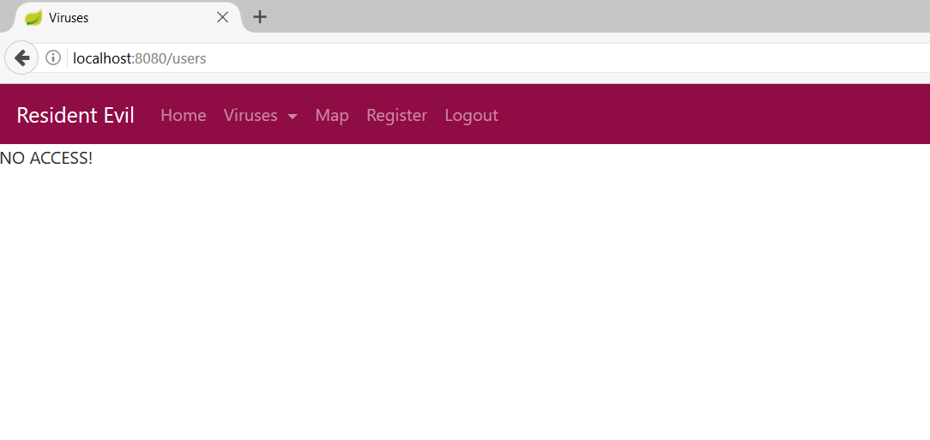

## Users Page

Create a page that lists all the **users**. I should be accessible only for **Admins**.

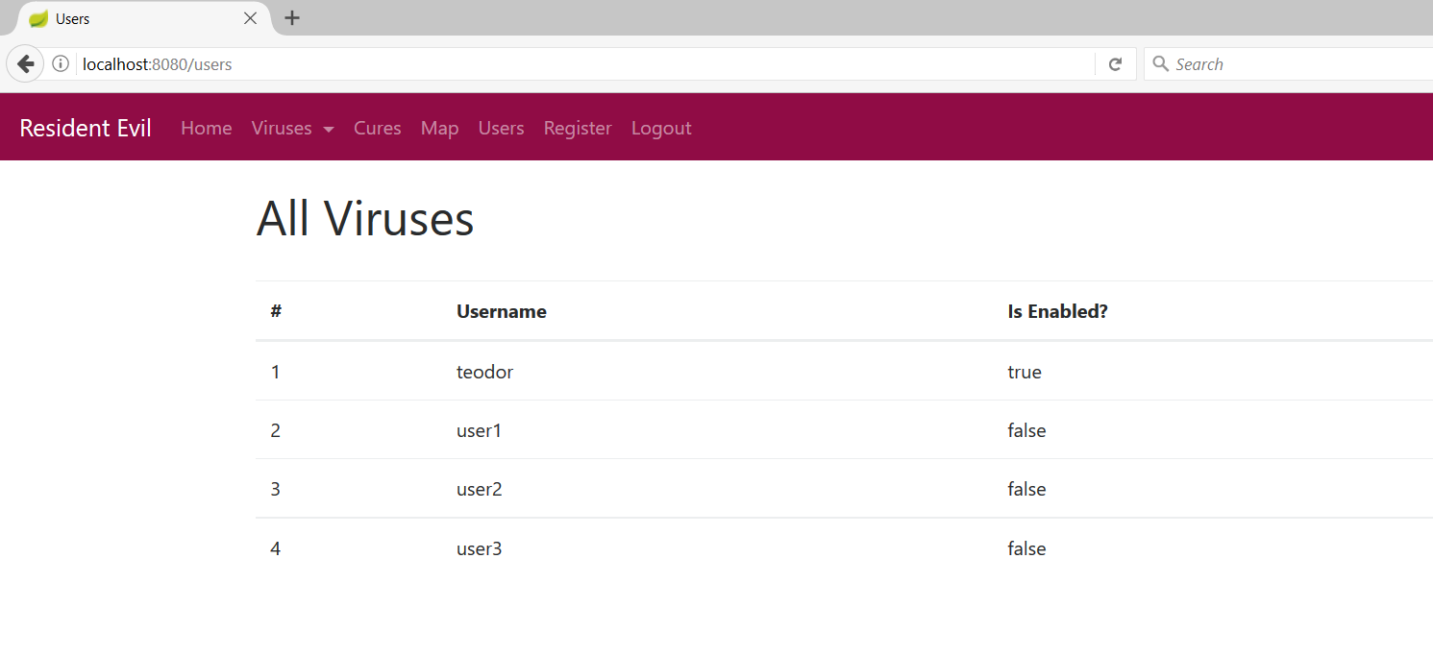

## UI Authorization

Edit the **home view** by using **Thymeleaf Security:**

* If you are **anonymous** you should see **Login** section
* If you are **logged in** you should see **Logout** section
* If you are **Admin** you should see **all** sections
* If you are **Medic**, you should **not** see **Viruses** and **Users**
* If you are **Chemist**, you should **not** see **Cures** and **Users**

## Bonus: Add Edit option for the Users

In the **Users** section add panel to **edit** users. You can assign them **roles**. This option will should be **accessible** only for **admins**. Use whatever **design** you prefer.